IT24103187 - PS Lab 08

**Question 1**

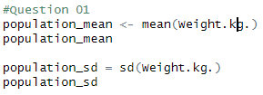

**Question 2**

**Question 3**

